Low Level Design (LLD)

Estimation of Energy Efficiency of Residential Buildings

Revision Number: 1.0

Last date of revision: 02/06/2021

Mayur Rathod

# 

# Document Version Control

|  |  |  |  |
| --- | --- | --- | --- |
| Date Issued | Version | Description | Author |
| 18th May 2020 | 1.0 | First Draft | Mayur Rathod |
|  |  |  |  |

**Contents**

Document Version Control 2

**Abstract** 4

1 Introduction 5

1.1 Why this Low-Level Design Document? 5

1.2 Scope 6

1.3 Constraints 6

1.4 1.3 Risks 6

1.5 1.4 Out of Scope 7

2 Technical specifications 7

2.1 Predicting Disease 7

2.2 Logging 7

2.3 Database 7

3 Technology stack 8

4 Proposed Solution 9

5 Model training/validation workflow 10

6 User I/O workflow 12

7 Exceptional scenarios 13

**Abstract**

When designing and building a new energy-efficient house, and it can be a challenge. However, recent technological improvements in building elements and construction techniques also allow most modern energy saving ideas to be seamlessly integrated into house designs while improving comfort, health, or aesthetics. And even though some energy-efficient features are expensive, there are others that many home buyers can afford. While design costs, options, and styles vary, most energy-efficient homes have some basic elements in common: a well-constructed and tightly sealed thermal envelope; controlled ventilation; properly sized, high-efficiency heating and cooling systems; and energy-efficient doors, windows, and appliance.

Our Energy Efficiency project helps to predict the values of these heating and cooling load.

# Introduction

## Why this Low-Level Design Document?

The purpose of this document is to present a detailed description of the Energy Efficiency System. It will explain the purpose and features of the system, the interfaces of the system, what the system will do, the constraints under which it must operate and how the system will react to user input. This document is intended for both the stakeholders and the developers of the system and will be proposed to the higher management for its approval.

The main objective of the project to use a number of classical and non-parametric statistical analytic tools to carefully analyse the strength of each input variable's correlation with each of the output variables to predict the value of heating load and cooling load.

An Energy Efficiency contains information, such as:

* Relative Compactness
* Surface Area
* Wall Area
* Roof Area
* Overall Height
* Orientation
* Glazing Area
* Glazing Area Distribution
* Heating Load
* Cooling Load

This project shall be delivered in two phases:

Phase 1: All the functionalities with PyPi packages.

Phase2: Integration of UI to all the functionalities.

## Scope

This software system will be a Web application This system will be designed to predict the values of these heating and cooling load. This system is designed to predict the load values from building area shapes information such as Relative Compactness, Surface Area, Wall Area, Roof Area, Overall Height, Orientation, Glazing Area, Glazing Area Distribution, Heating Load, Cooling Load.

# Technical specifications

## 2.1 Dataset

We get data from [this](https://archive.ics.uci.edu/ml/datasets/energy+efficiency) link. The dataset is of Energy efficiency for building.

## 2.1.1 Diabetes dataset overview

We perform energy analysis using 12 different building shapes simulated in Ecotect. The buildings differ with respect to the glazing area, the glazing area distribution, and the orientation, amongst other parameters. We simulate various settings as functions of the afore-mentioned characteristics to obtain 768 building shapes. The dataset comprises 768 samples and 8 features, aiming to predict two real valued responses. It can also be used as a multi-class classification problem if the response is rounded to the nearest integer.

* Data table

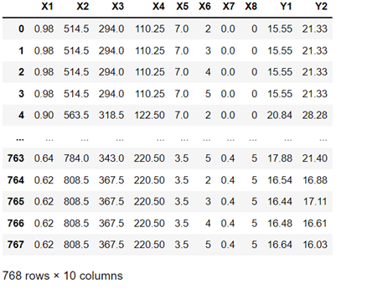

## 2.1.2 Input schema

|  |  |  |
| --- | --- | --- |
| **Feature name** | **Datatype** | **Null/Required** |
| Relative Compactness | float | Required |
| Surface Area | float | Required |
| Wall Area | float | Required |
| Roof Area | float | Required |
| Overall Height | float | Required |
| Orientation | int | Required |
| Glazing Area | float | Required |
| Glazing Area Distribution | int | Required |

## 2.2 Prediction

* The system displays labels.
* The User enters the values.
* The system presents the get the inputs from the user.
* The user gives required information.
* The system should be able to predict the value of heating load and cooling load

## 2.3 Logging

We should be able to log every activity done by the user.

* The System identifies at what step logging required
* The System should be able to log each and every system flow.
* Developers can choose logging methods. You can choose database logging/ File logging as well.
* System should not be hung even after using so many loggings. Logging just because we can easily debug issues so logging is mandatory to do.

## 2.4 Database

System needs to store every request into the database and we need to store it in such a way that it is easy to retrain the model as well.

1. The User chooses the disease.

2. The User gives required information.

3. The system stores each and every data given by the user or received on request to the database. Database you can choose your own choice whether MongoDB/ MySQL.

**2.5 Deployment**

1. Heroku



# Technology stack

|  |  |
| --- | --- |
| **Front End** | HTML/CSS/JS |
| **Backend** | Python Flask |
| **Database** | MongoDB/MySql |
| **Deployment** | AWS/Heroku |

# Model training/validation workflow

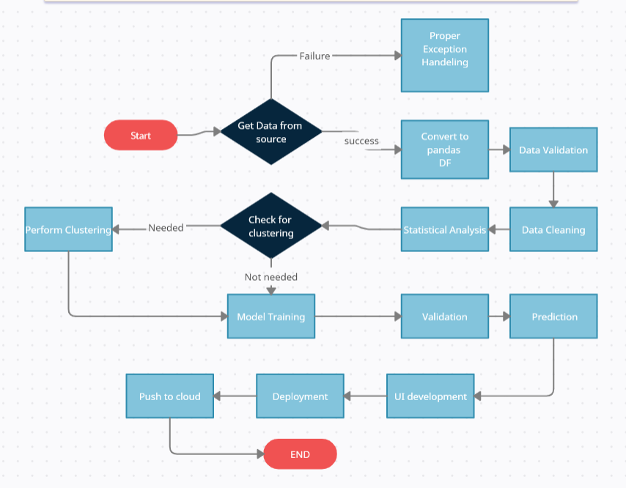

# User I/O workflow

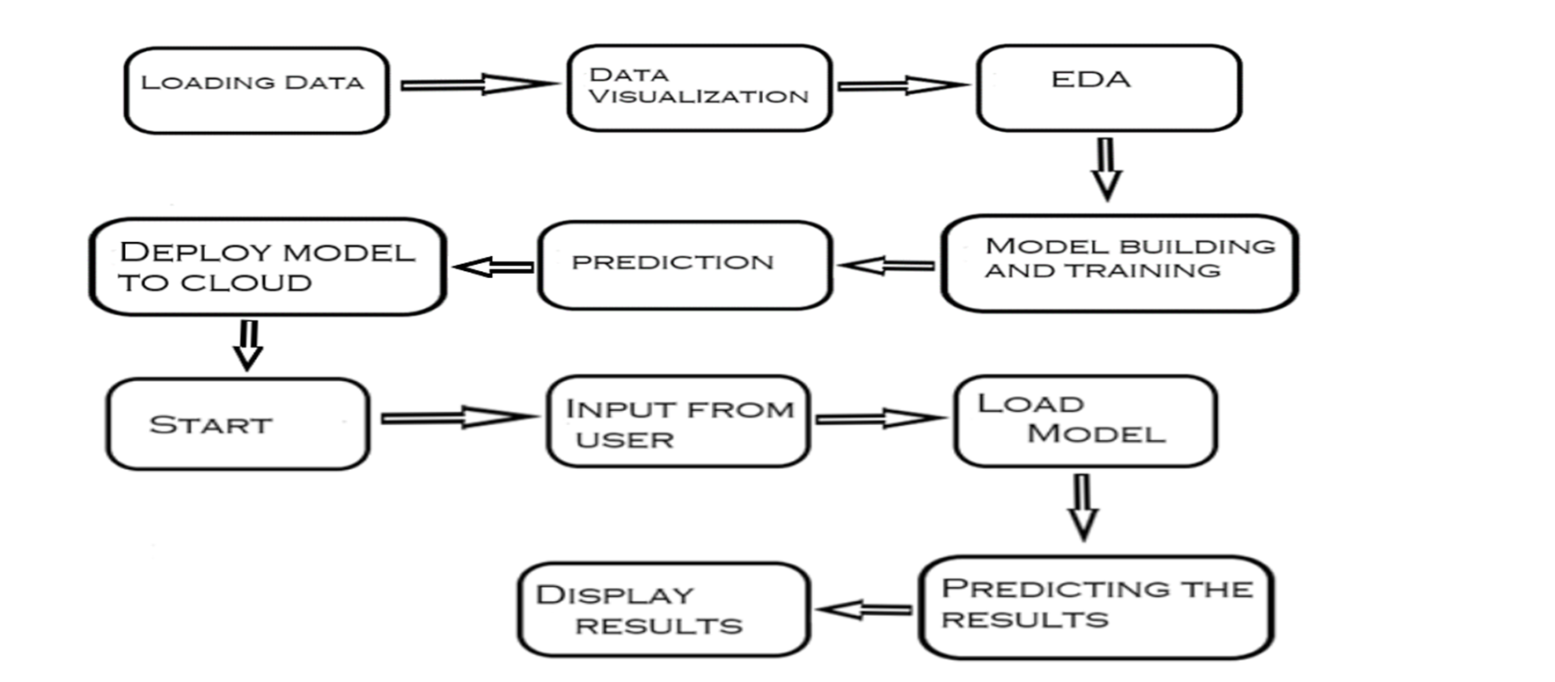

# Key performance indicators (KPI)

* Time and workload reduction using the Energy efficiency model.
* Comparison of accuracy of model prediction and engineer’s prediction.
* Shapes of buildings/attributes.